**Analysis of patterns and anomalies in judgments against the State handled by the National Agency for Legal Defense**

Basic EDA

TEAM 12

Brayan Andru Montenegro Embus

Juan Esteban López de mesa

Cristian Camilo Lopez Martinez

Valeria García Múnera[¶](http://localhost:8888/notebooks/Documents/curso%20de%20ciencia%20de%20datos/Agencia%20Nacional%20de%20Defensa%20Jur%C3%ADdica%20del%20Estado/proyecto/ds4a_proyecto/anali.ipynb#Valeria-García-Múnera)

Camilo Andrés Serrano Velandia.

review of the number of favorable and unfavorable awards. this being the variable of interest, it is found that the number of favorable and unfavorable awards is similar.

When reviewing the words that are most repeated within the fact variable, we find that the word CONTRACT, CONTRACTOR, PARTY and PAYMENT are highlighted. These are the ones that are most frequently found and therefore can be one of the main factors of demands to the state, this point will be reviewed in more depth.

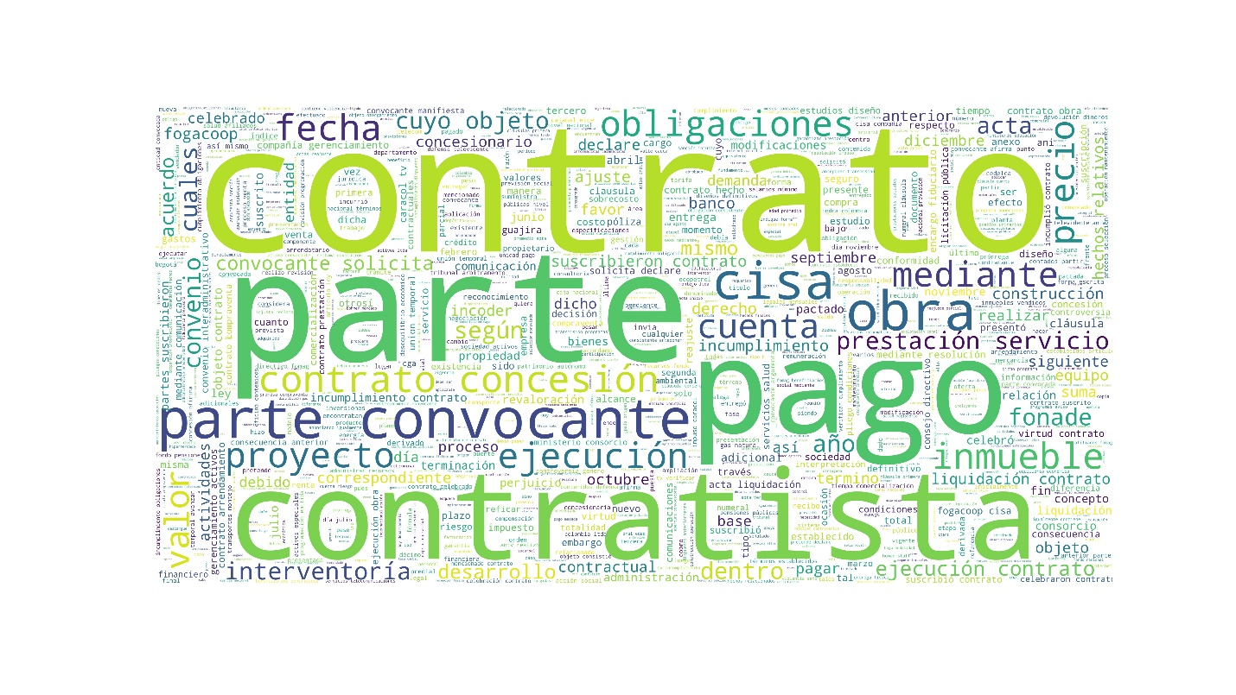

Next, the exploration of other variables will be carried out, each of the variables will be reviewed with respect to the number of failures, in order to determine if any of them has a type of bias in the failure

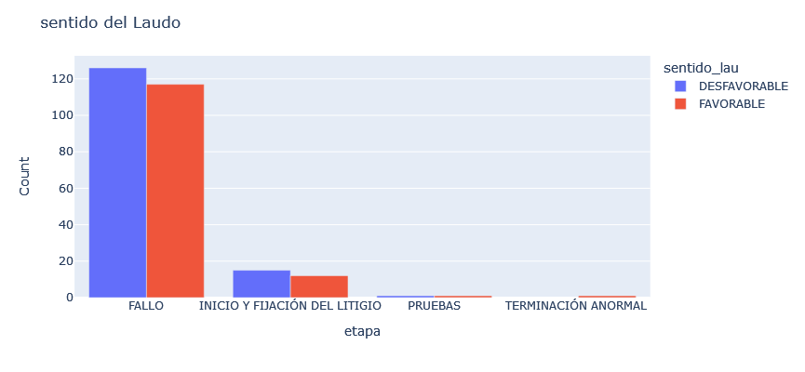

When looking for some type of payment by the state, it is observed that the number of unfavorable rulings is high.

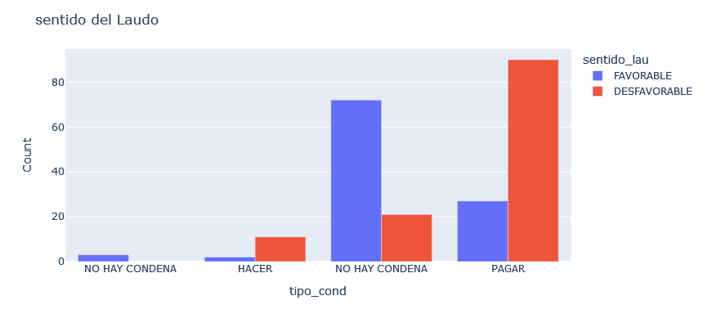

When the amounts of the demands are high, it is observed that most of the rulings are unfavorable, therefore the state is forced to pay billions of pesos.

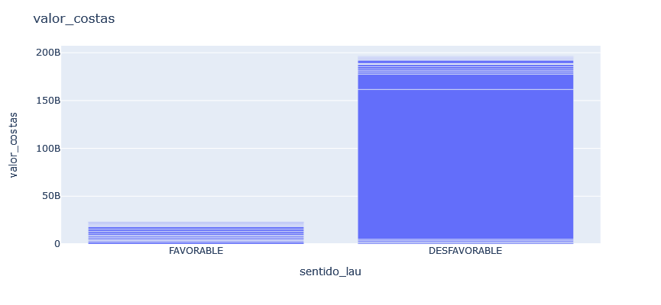

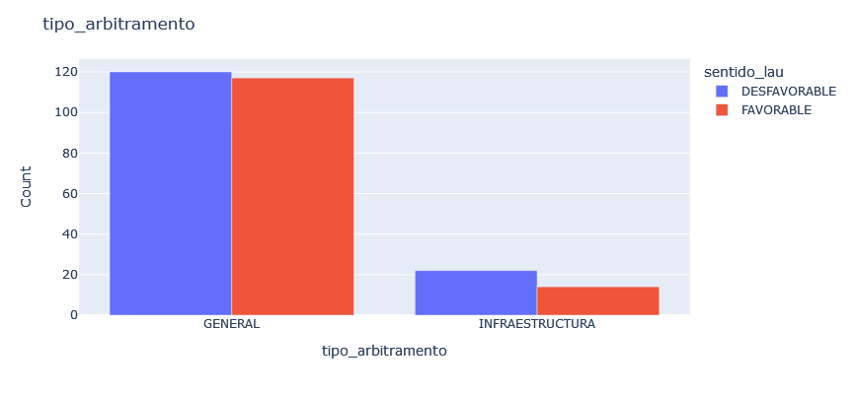



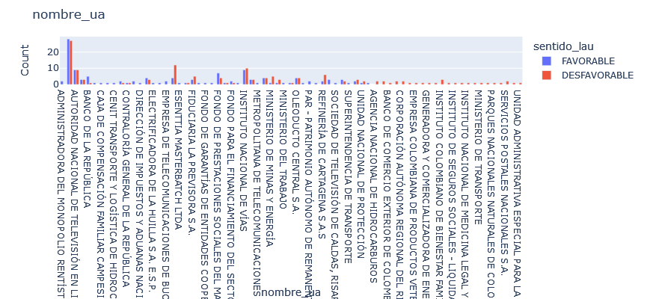

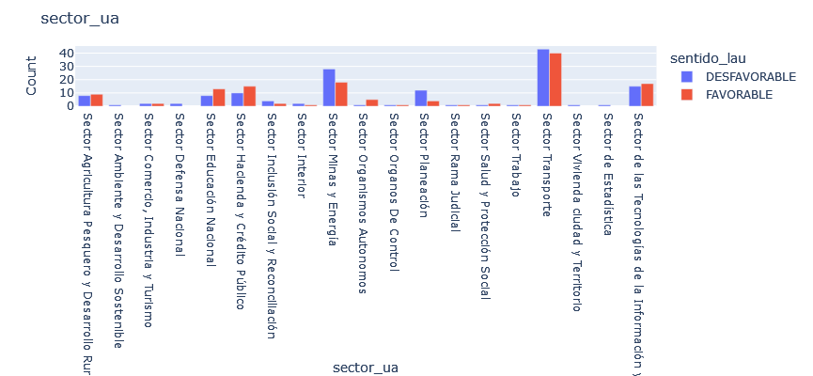

The univariate analysis of each column is done to check that there are no inconsistencies. The first variable to analyze is entity_id.

It was found that there are a number of institutions that tend to lose a greater number of rulings, in addition there are other entities that are sued more frequently, being the national television authority the one that presents the greatest number of lawsuits.

There are no null values in the IDs. However, there seem to be IDs with an atypical number of digits (other than three), which may be due to a typing error:

Most lawsuits have amounts in "pesos", followed by "dollars" and finally "minimum monthly wages"

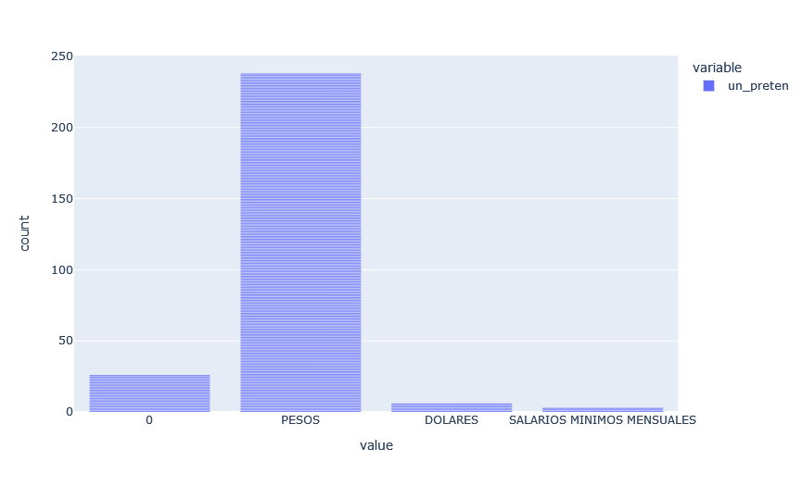

On the other hand, it is noted that the values are quite high and there are atypical data since the distribution has a positive bias.

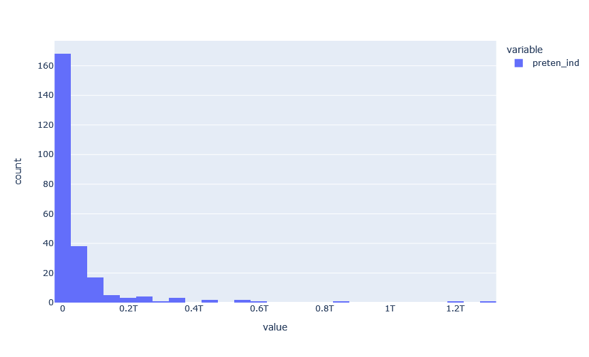

The variable value_ini_ind has a similar behavior with some differences:

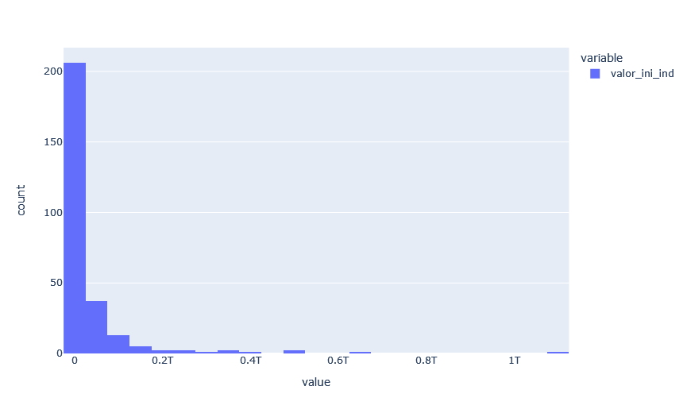

This is the top 5 of counterparts, summoned and summoners:

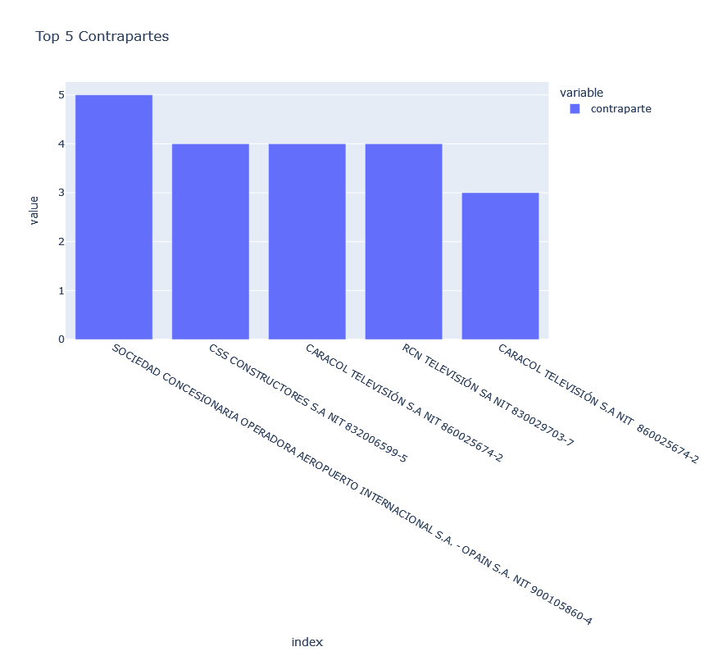

Most of the awards are resolved in the first instance, a very low proportion of the cases in the database present a resolution in the second instance due to the filing of appeals. The instances framed under the extraordinary resource may be related to high amounts. In the case of the ruling, it may mean that they can be reviewed by a judge

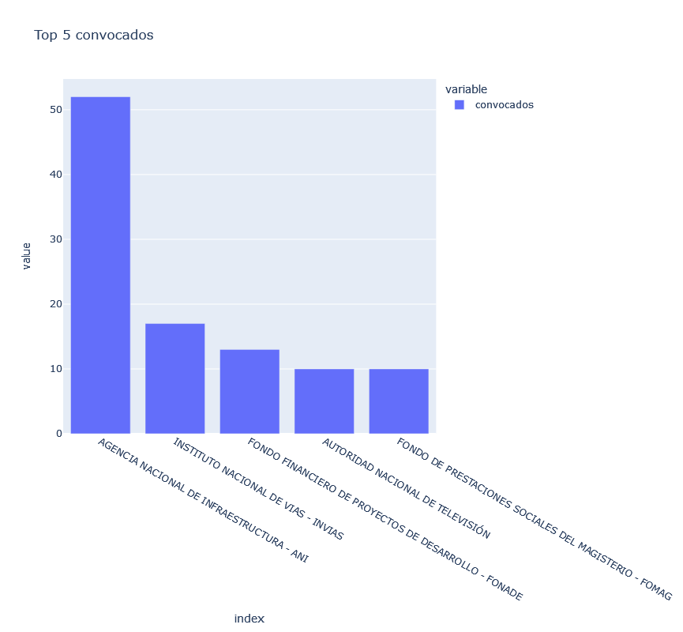

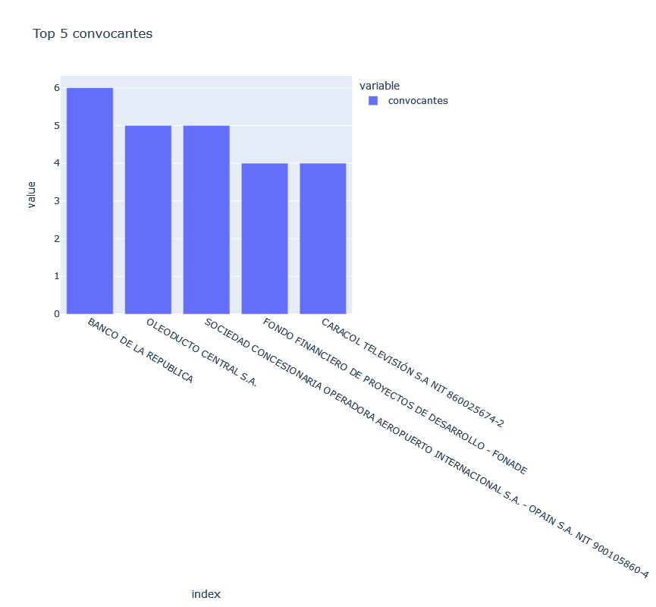

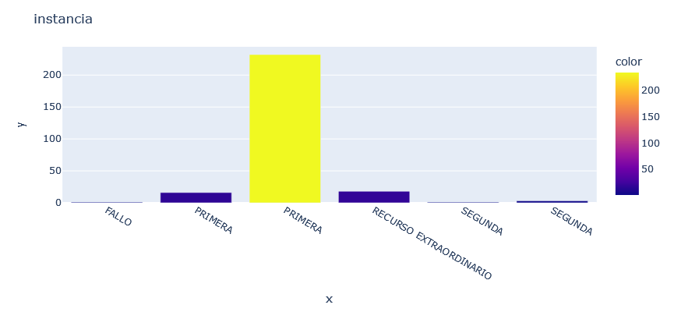

Most of the awards are in the judgment stage, a low proportion is in the evidence stage and a few cases are in the abnormal termination stage that perhaps refers to a kind of conciliation conciliation

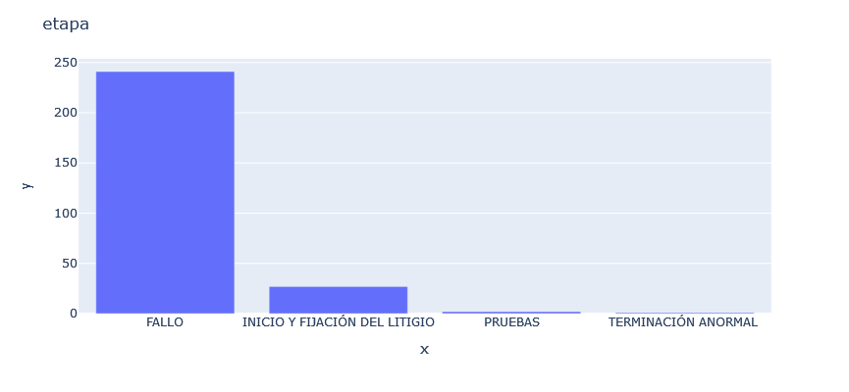

Most cases of arbitration selection occur by mutual agreement between the parties, but a large proportion is chosen by lottery generally used by the arbitration center. The process must be studied in depth to establish why in some cases the decision rests with a civil judge

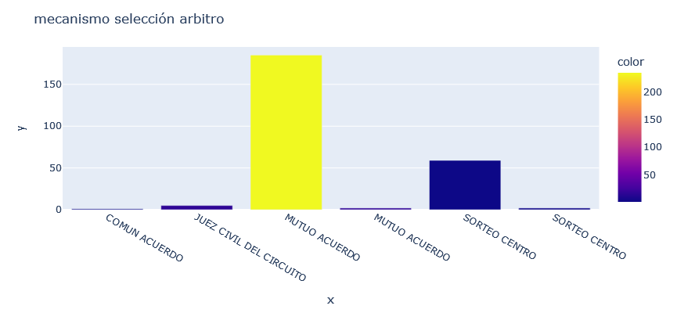

The issue of the secretaries deserves special attention, since the distribution should tend to be more uniform, but there are about 8 arbitrators who concentrate almost half of the cases

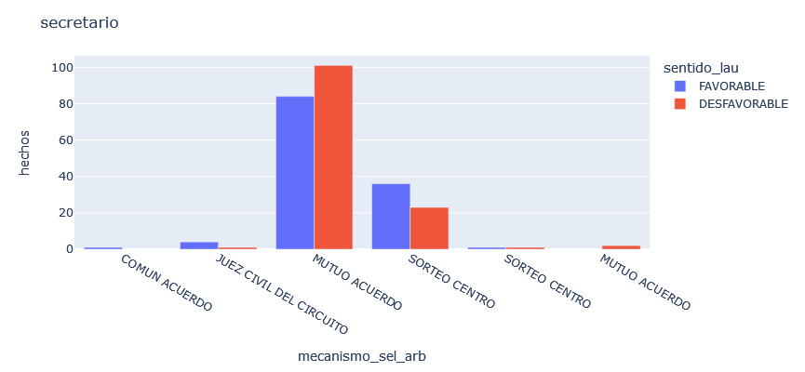

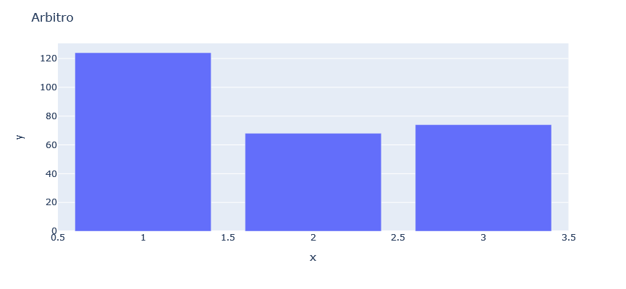

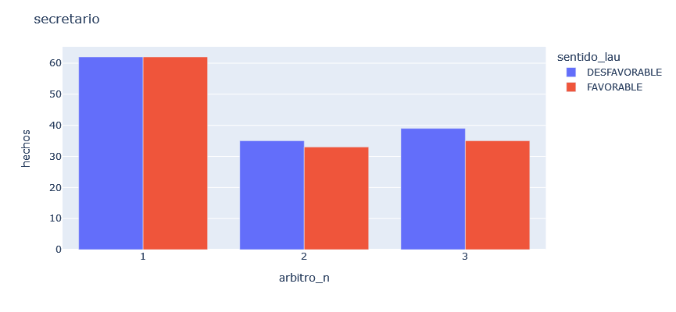

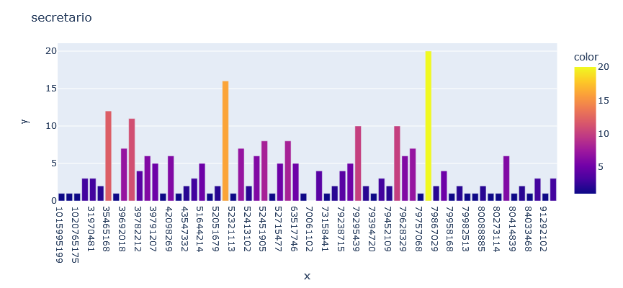

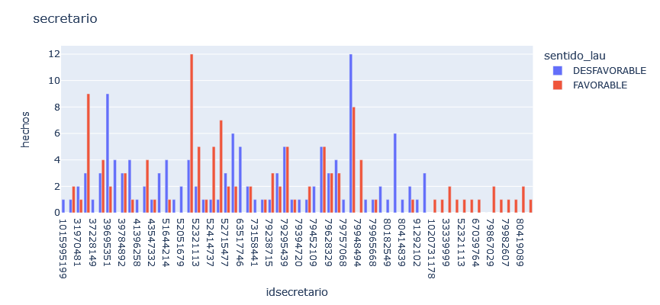

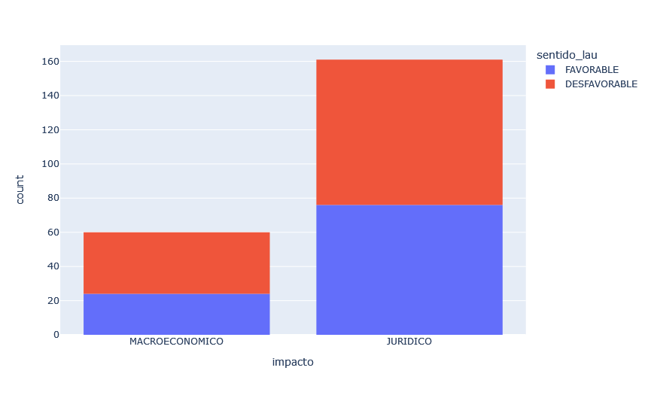

The impact of the awards is divided between legal and macroeconomic, with the legal impact being the one with the largest number of arbitral awards with approximately 60%, while the macroeconomic impact has 20% of arbitral awards and the remaining 20% of arbitral awards has no definite impact.

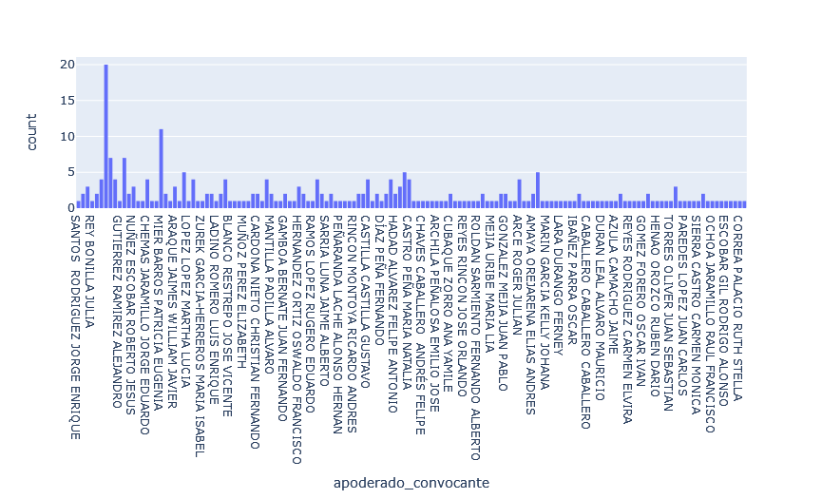

There are 146 attorneys-in-fact of the calling party, where it is observed that the majority have handled 1 or 2 cases and a maximum of 11 cases per attorney-in-fact. There are 20 arbitral awards that do not have information on the attorney of the calling party.

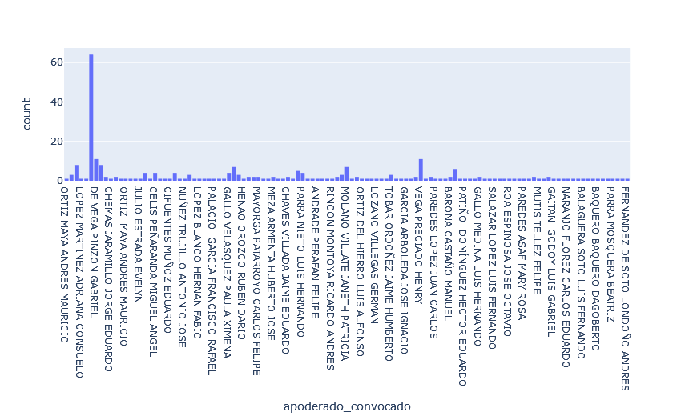

There is complete information on the attorneys of the summoned party for all arbitral awards, in total there are 115 attorneys of the summoned party with a maximum of 11 cases handled by the same attorney, but most have only been appointed for a single process.

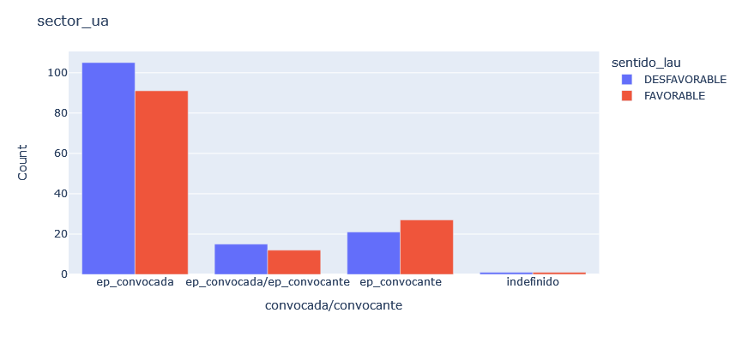

More than 80% of the public entities participate as convened, within which a prevailing sense of the unfavorable award is observed. On the other hand, the public entities that act as conveners are less than 30% and for these there is a predominant sense of favorable award. There are cases in which public entities act both as conveners and conveners, this may be due to the fact that there are entities that are mixed that have part of their public administration and a private part.